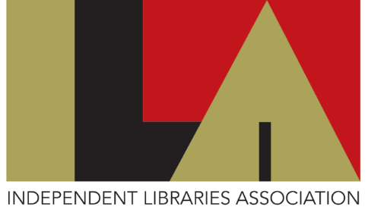

MEMBERSHIP APPLICATION FORM FOR INDIVIDUAL SUPPORTERS

This form has been made available in Word format to enable you to complete it on-screen so that you may submit it by email to Hon Secretary and Membership Secretary, Kay Easson, keasson@litandphil.org.uk. Please see below for payment details and postal address.

1. | Name
2. | Address
3. | Telephone
4. | Email
5. | Are you a member of an ILA institution?  (If so, please say which)
6. | How did you hear about us?

SUBSCRIPTION RATE April 2021 to March 2022
Individual Supporters | £10.00

Please make payment by direct bank transfer to the Independent Libraries Association account at:

Sort code 12 08 95 Account No 00176590 Reference: SUPP-SUB

or send cheque payment with this form (if you prefer to post this) to:

Kay Easson, Librarian, The Literary and Philosophical Society of Newcastle, 23 Westgate Road, Newcastle-upon-Tyne NE1 1SE

INFORMATION FOR ILA SUPPORTERS

Please note: Individual Supporters will receive news of conferences, seminars and workshops but must contact, beforehand, any institution they may wish to visit to enquire about access.

The ILA does not currently produce a newsletter, due to resource limitations. However, we have active and very interesting social media platforms where most of our libraries post news, views, photos, events, offers and more. The links are at the foot of these pages for our website, Facebook and Twitter. Please ‘like’ the Independent Libraries Association Facebook page and follow us on Twitter to receive information from all our other libraries for which we share postings.
The ILA is in the process of setting up its dedicated YouTube Channel and we hope to post events such as Conferences and Webinars, as well as, where possible, events from individual libraries.

May 2022

